Software Requirement Specification Document

For

Language Learning Portal System

Table of Contents
- Introduction
  - Purpose
  - Intended Customers/Users
  - Product Scope
  - Outline of the document
- Overall Description
  - Product Perspective
  - Product Functions
  - User Classes
  - Design and Implementation Constraints
- Diagrams
  - UML Diagrams
  - ER Diagrams
  - DFD Diagrams
- External Interface Requirements/Screenshots
  - User Interfaces
  - Hardware Interfaces
  - Software Interfaces
  - Communication Interfaces
- Other Non-Functional Requirements
  - Performance Requirements
  - Safety Requirements
  - Security Requirements
  - Software Quality Attributes
  - Business Policies/Rules (if any)
- Testing
  - Block-Box Testing
  - White-Box Testing
- Conclusion
- References
- Acknowledgements

Introduction
  - Purpose

The Language Learning Portal System is being created to give students a one-stop, easy-to-use place to learn new languages. It’s designed to help learners boost their language skills through organized lessons, fun practice exercises, and quizzes, all available online so you can study at your own pace.

  - Intended Customers/Users

- Students:Individuals who want to learn new languages or improve existing language skills using lessons, exercises, and assessments.
- Instructors: Language teachers who create courses, upload learning materials, assign exercises, and evaluate learner performance.

  - Product Scope
The Language Learning Portal System is a web-based application designed to support language learning through structured and interactive digital resources. The system enables learners to enrol in language courses, access multimedia lessons, and practice language skills using exercises and quizzes.
It allows instructors to create and manage courses, upload learning materials, design assessments, and track learner performance. The system also provides progress monitoring features such as scores, completion status, and performance analytics to help learners understand their improvement over time.
Administrators will have control over user management, content moderation, course availability, and overall system configuration. The portal aims to provide a flexible, scalable, and user-friendly learning environment that supports self-paced learning and effective language skill development.

  - Outline of the document

- Chapter 1: Introduction
Provides an overview of the system, including the purpose of the document, intended users, product scope, and the structure of the SRS.
- Chapter 2: Overall Description
Describes the overall functioning of the system, including its perspective, major functions, user classes, and design or implementation constraints.
- Chapter 3: Diagrams
Presents system design representations such as UML diagrams, ER diagrams, and Data Flow Diagrams (DFDs), along with assumptions and dependencies.
- Chapter 4: External Interface Requirements / Screenshots
Explains how the system interacts with users and external systems, including user interfaces, hardware interfaces, software interfaces, and communication interfaces.
- Chapter 5: Other Non-Functional Requirements
Details non-functional aspects such as performance, safety, security, software quality attributes, and applicable business rules or policies.
- Chapter 6: Testing
Describes the testing approaches used to verify the system, including black-box testing and white-box testing techniques.
- Chapter 7: Conclusion
Summarizes the overall system and highlights its importance and expected outcomes.
- Chapter 8: References
Lists all documents, books, websites, or other resources referred to while preparing this document.
- Chapter 9: Acknowledgements
Expresses gratitude to individuals or organizations that supported the development of the project.

Overall Description

  - Product Perspective

The Language Learning Portal System is a web-based application that works in an online environment. It is not a standalone system; it operates as part of a larger educational platform. The system requires an internet connection and runs on web browsers. It interacts with external systems such as a database to store user details, course content, and progress records, a payment gateway, an email or notification service to send alerts, verification links, and updates. The system allows students, instructors, and administrators to access it from any device such as a laptop, tablet, or mobile phone.

  - Product Functions

The main functions of the Language Learning Portal System include:
- User registration and login
- Language course enrollment
- Access to lessons in text, audio, and video format
- Practice exercises and quizzes
- Automatic evaluation and score generation
- Progress tracking for students
- Course and content creation by instructors
- Student performance monitoring by instructors
- User and course management by administrators

  - User Classes

The system supports the following types of users:
- Students: can register, log in, enroll in courses, view lessons, take quizzes, and track their progress.
- Instructors: Can create and manage courses, upload learning materials, prepare quizzes, and view student performance.
- Administrators: Can manage users, approve or remove courses, control system settings, and generate reports.

  - Design and Implementation Constraints

The system has the following limitations and constraints:
- Hardware limits: Users need a device such as a computer, tablet, or smartphone.
- Software requirements: The system requires a web browser such as Chrome, Edge, or Firefox.
- Regulatory rules: User data must be handled according to data protection and privacy rules.
- Network dependency: A stable internet connection is required to access the system.
- Browser-specific issues: The system may not work properly on outdated browsers.
- Security constraints: User data must be protected using authentication, passwords, and secure connections.

Diagrams
3.1 UML Diagrams
USE CASE DIAGRAM

- Learning New Language
Description:This use case diagram represents the complete flow of a customer (student) enrolling in and completing a language learning course on the portal, along with the interaction of an instructor who teaches the course. The system supports language selection, enrolment, subscriptions, attending classes, completing assignments, and course completion.

Primary Actor: Customer (Student)
Secondary Actor: Instructor

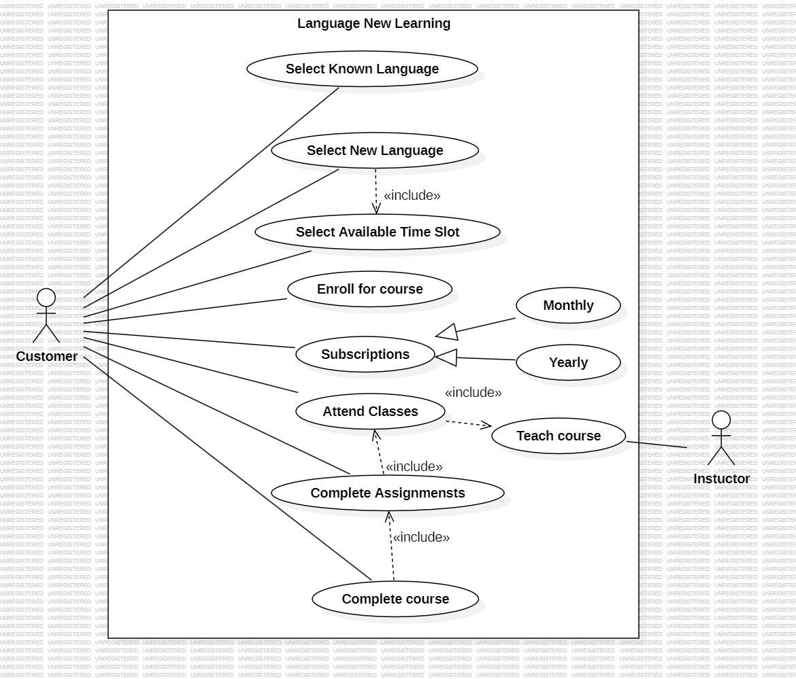
- 2. User Registration and Login
Description:This use case allows new users to register on the platform by providing basic details such as name, email, and password. Existing users can log in using their credentials. The system verifies the information and grants access based on user role.

Primary Actor: User, Instructor
Secondary Actor:Database

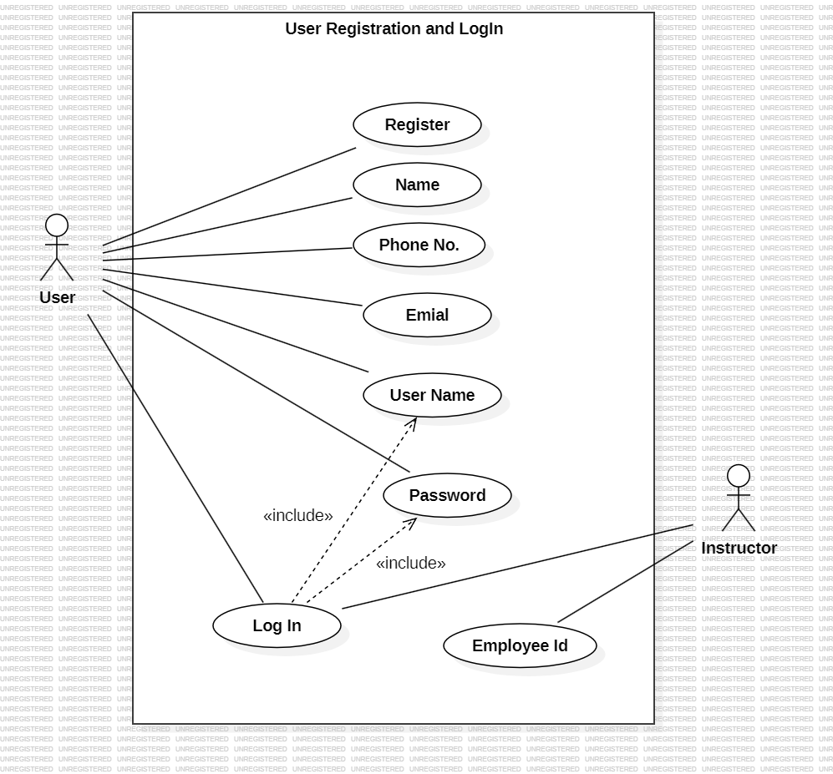
- Making Payment
Description: This use case enables the customer to make a secure payment for the selected subscription plan. The system redirects the user to a payment gateway, processes the transaction, and confirms successful payment.

Primary Actor:User
Secondary Actors: Bank System

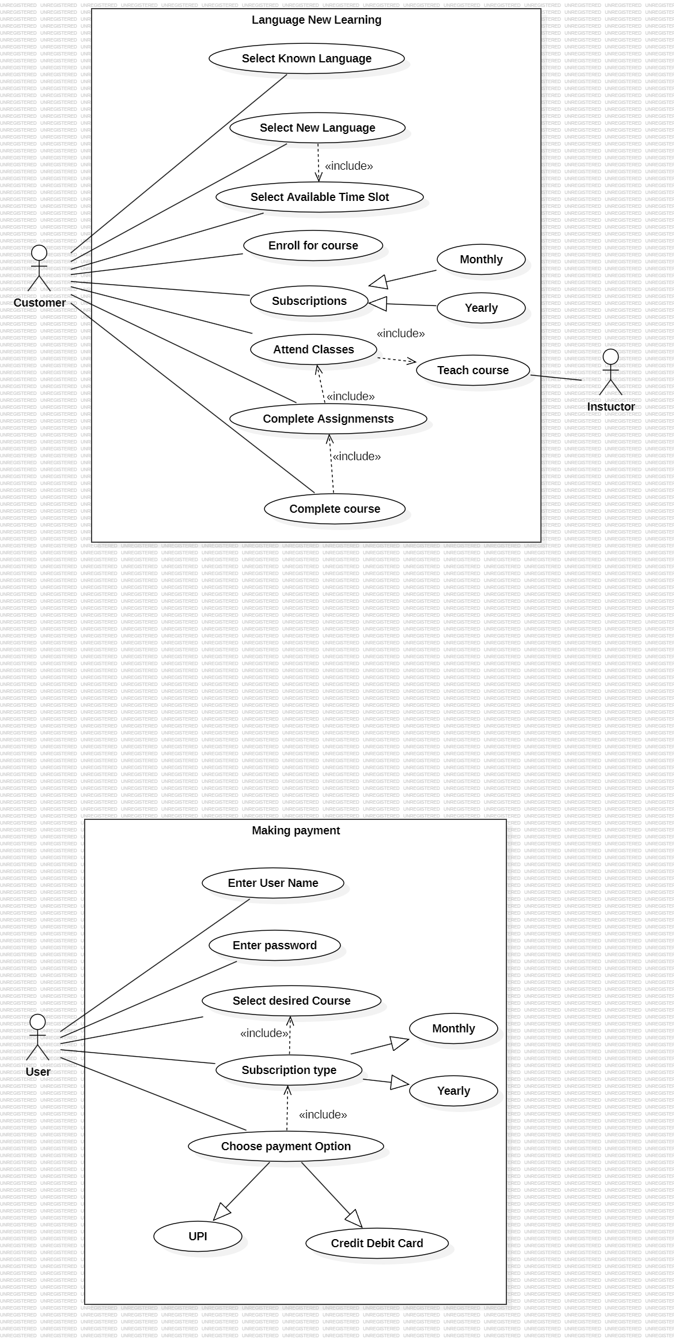
- Instructor Portal
Description:This use case allows instructors to access the instructor portal to manage teaching activities. Instructors can create and update courses, upload learning materials, schedule classes, conduct sessions, assign quizzes and assignments, and view student performance.

Primary Actor: Instructor
Secondary Actor: Database

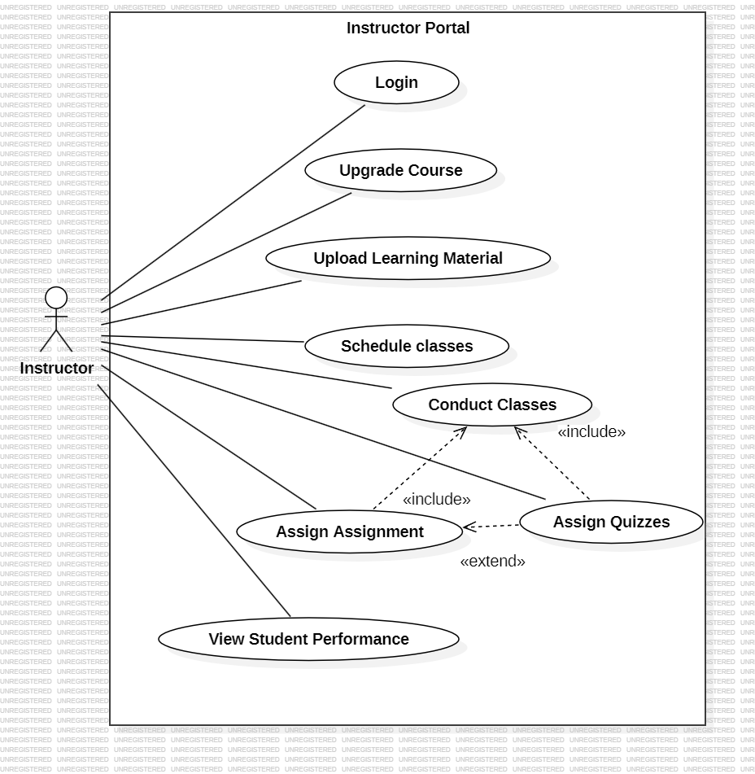
- Student Portal
Description:This use case allows students to access the student portal to manage their learning activities. Students attend online classes, access learning materials, attempt quizzes and assignments, and view their progress and results.

Primary Actor: Student
Secondary Actor: Database
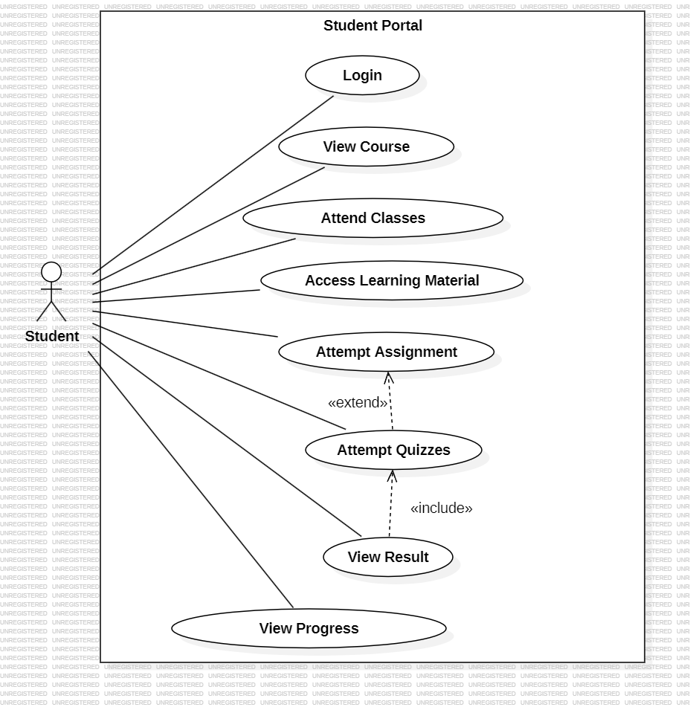

CLASS DIAGRAM

- Learning New Language
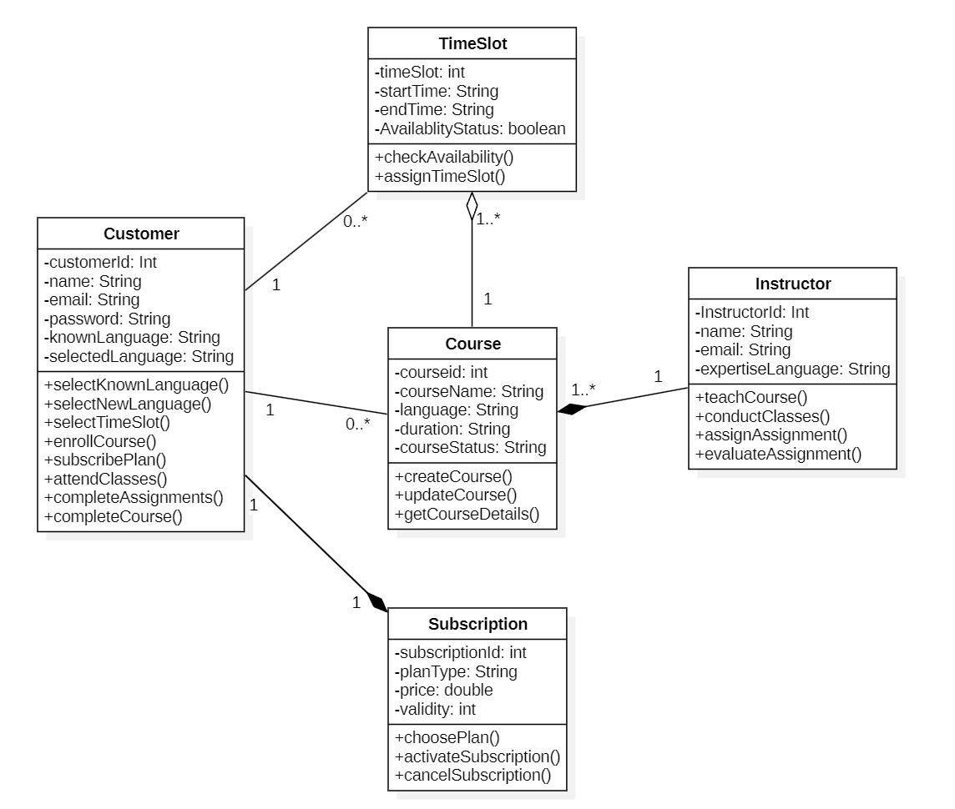

- User Registration and Login

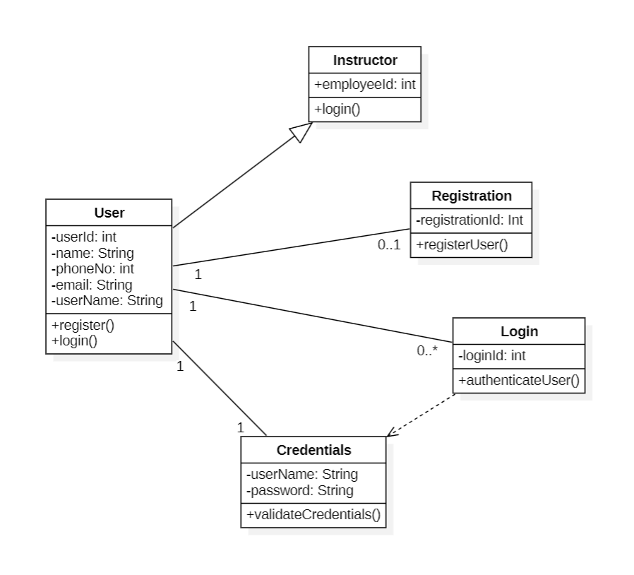

- Making Payment

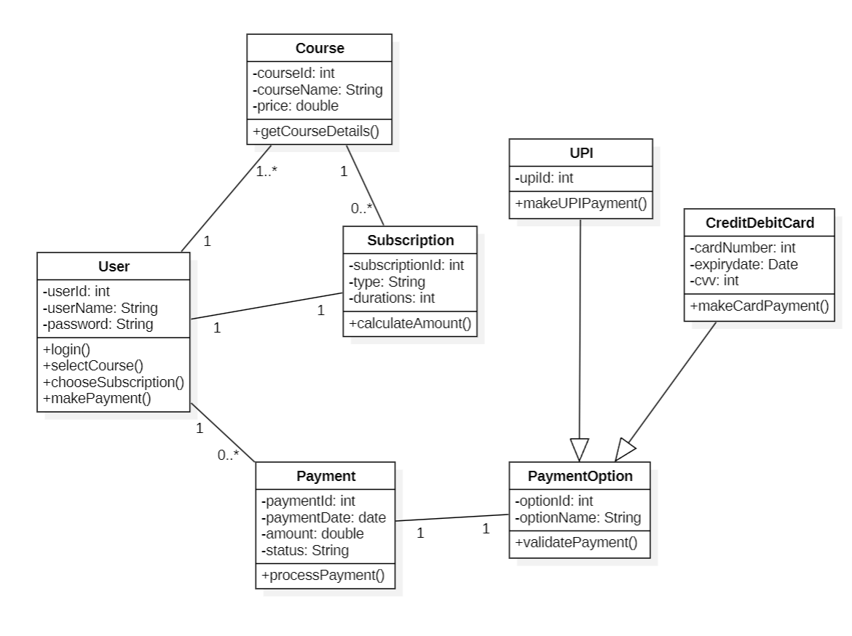
- Instructor Portal

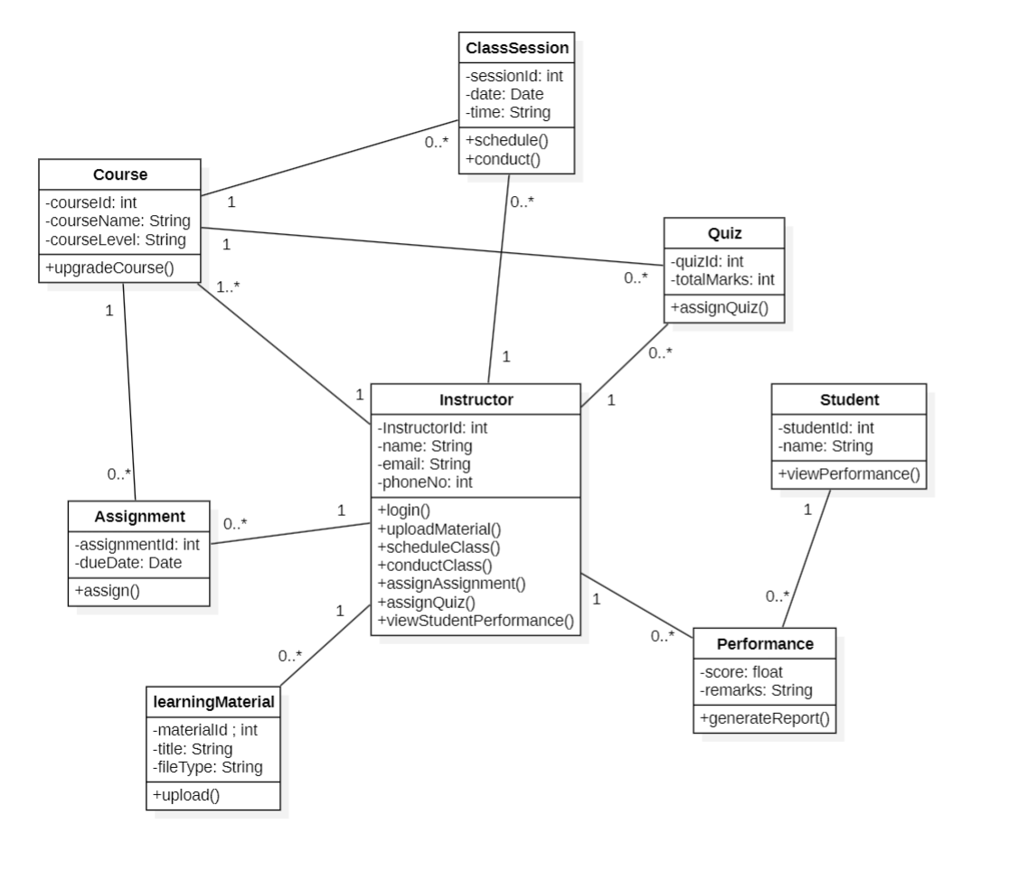

- Student Portal

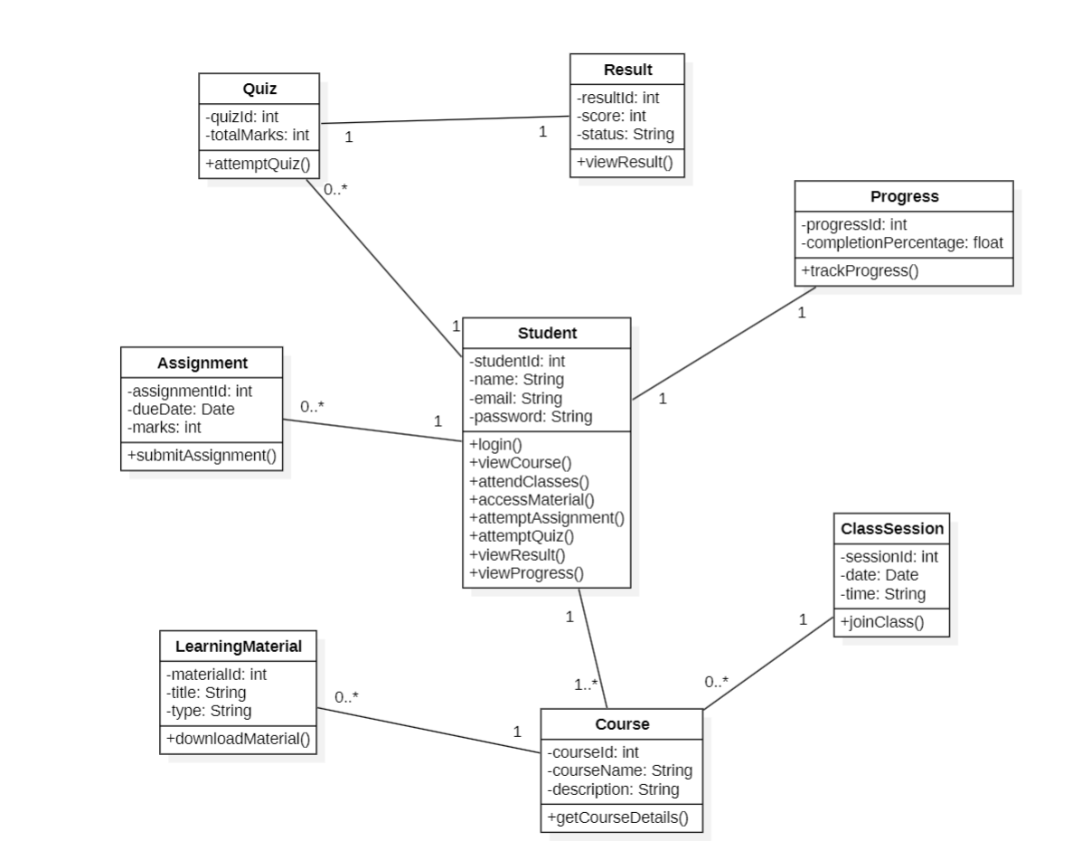
STATE DIAGRAM
LEARNING NEW LANGUAGE
CUSTOMER
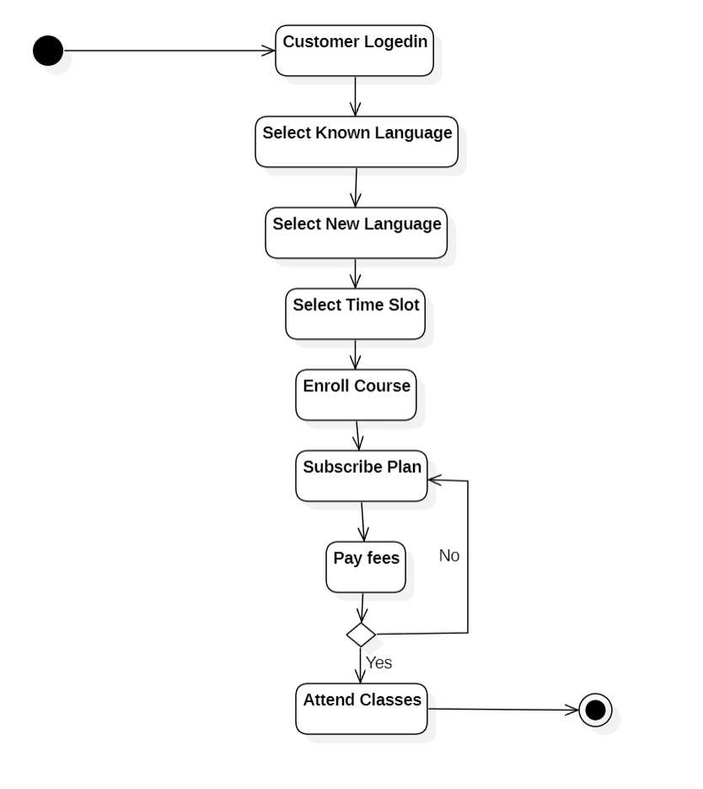

TIME SLOT

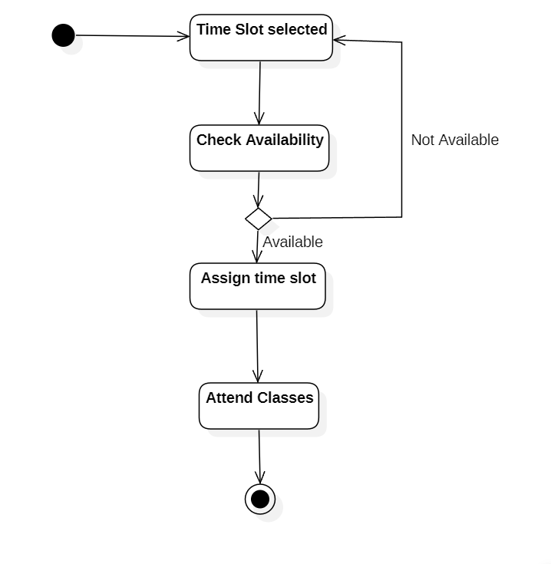

COURSE

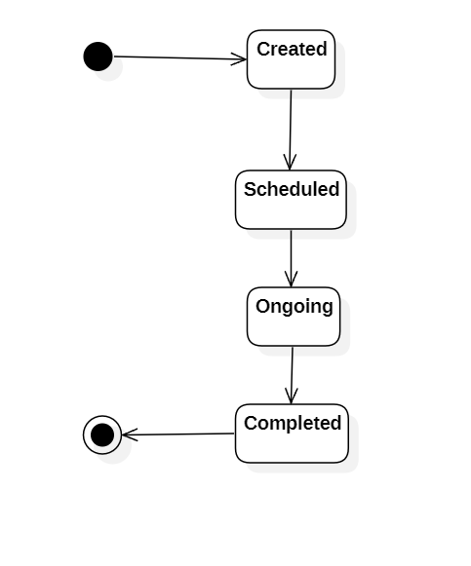
SUBSCRIPTION

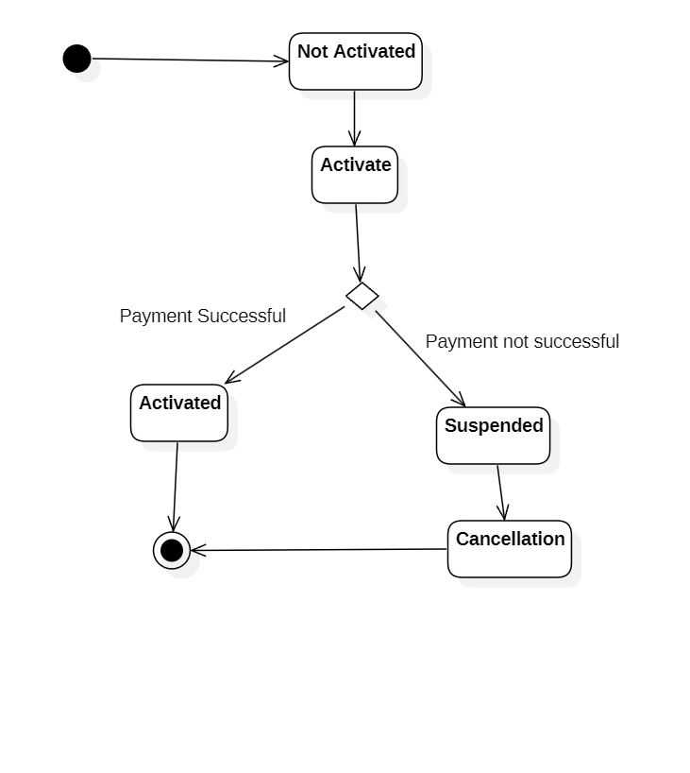
INSTRUCTOR

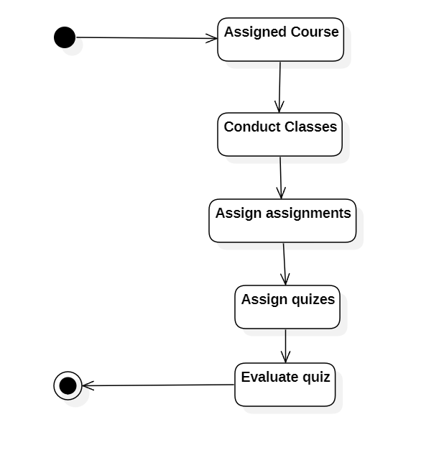

ACTIVITY DIAGRAM
STUDENT PORTAL

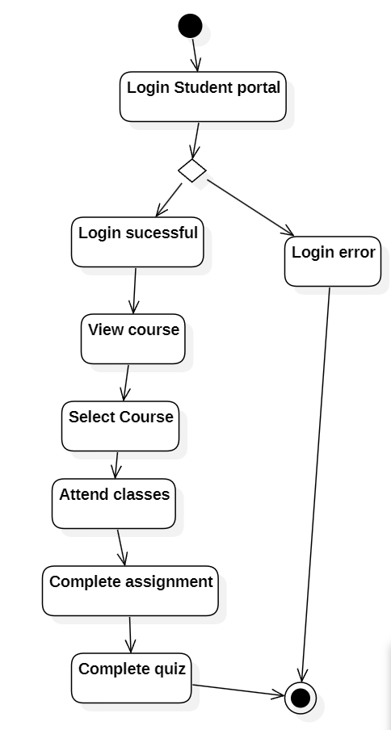
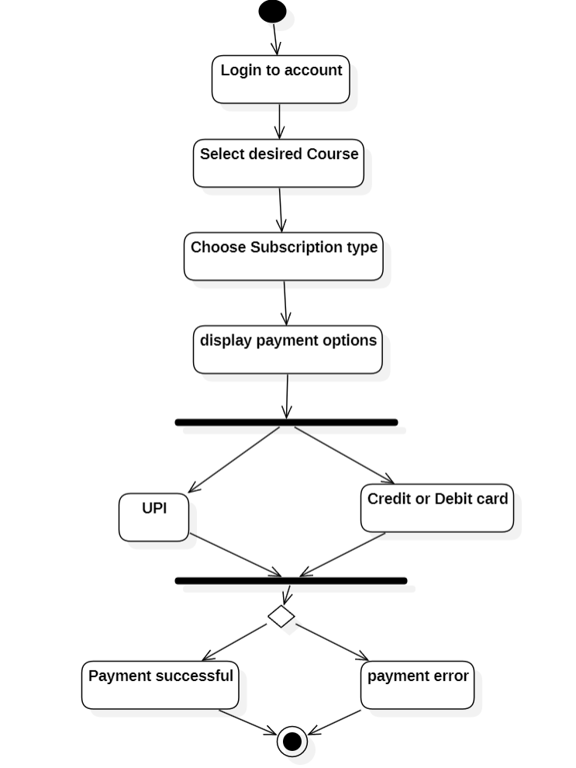
SUBSCRIPTION
SEQUENCE DIAGRAM

User Registration and Login

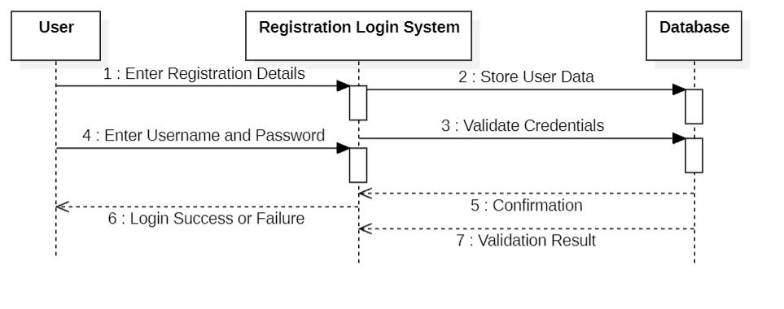
Student Portal
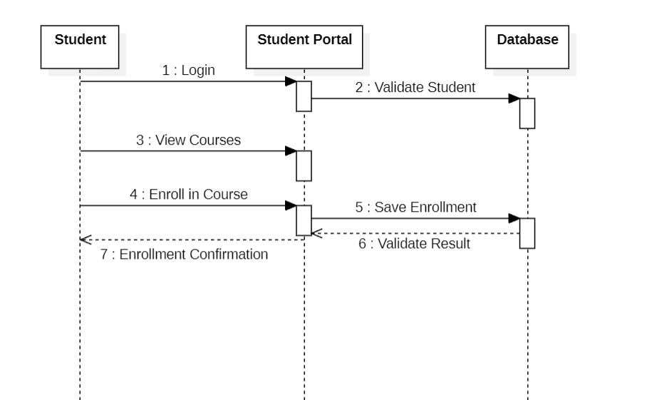

Instructor Portal
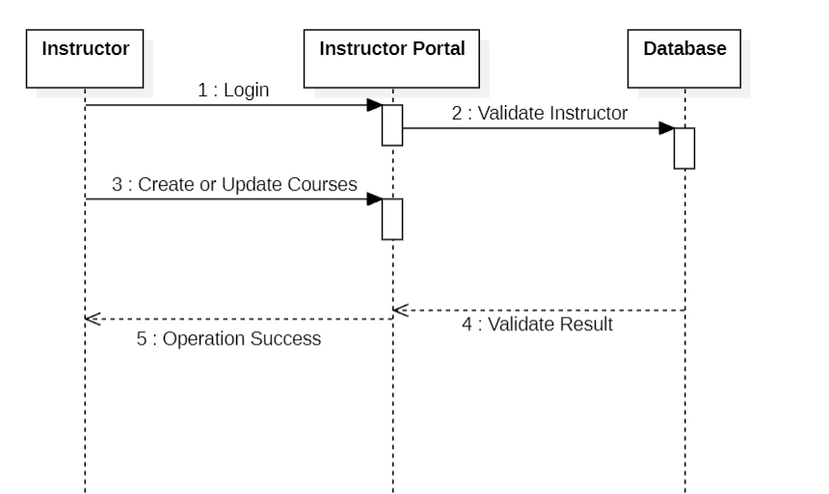

COLLABORATION DIAGRAM
User Registration and Login
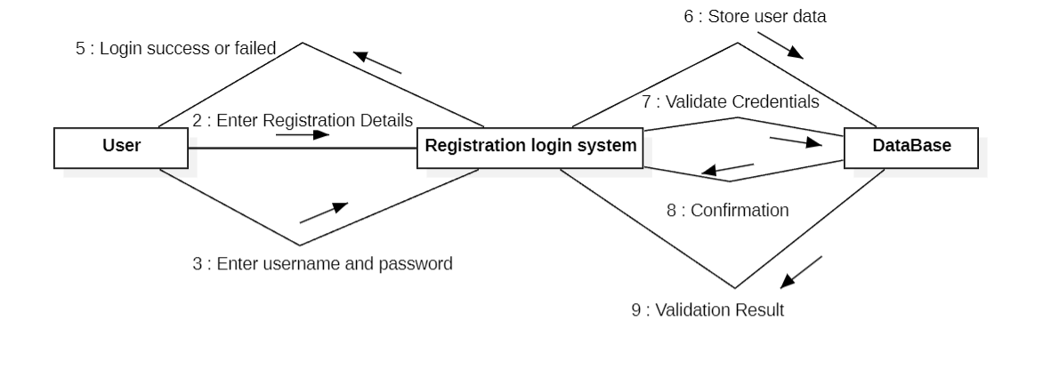

Student Portal

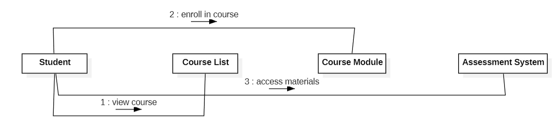
Instructor Portal

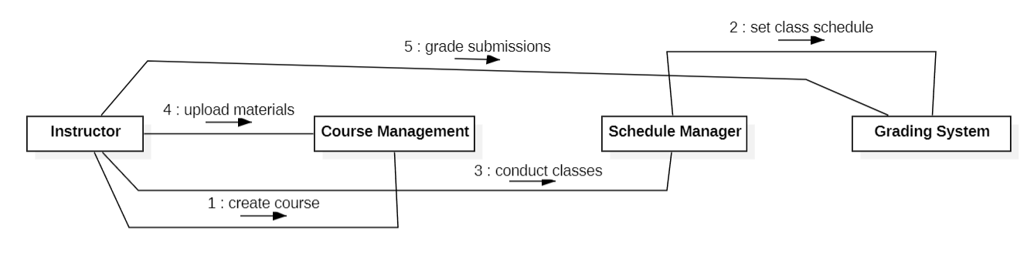

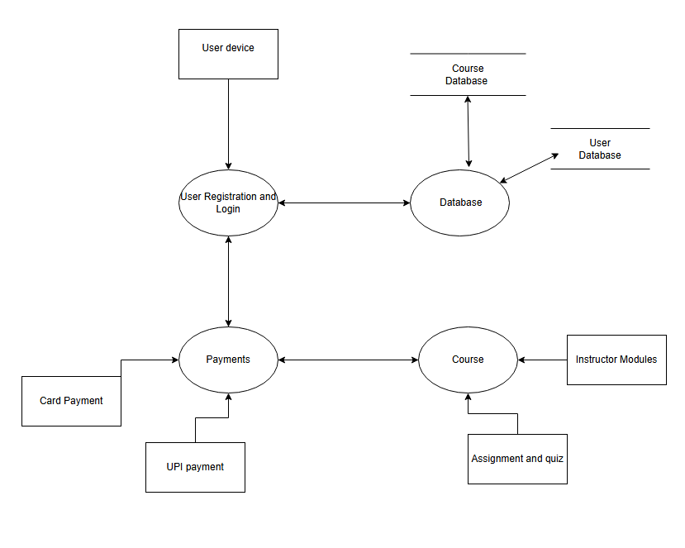
DFD (Level 1)
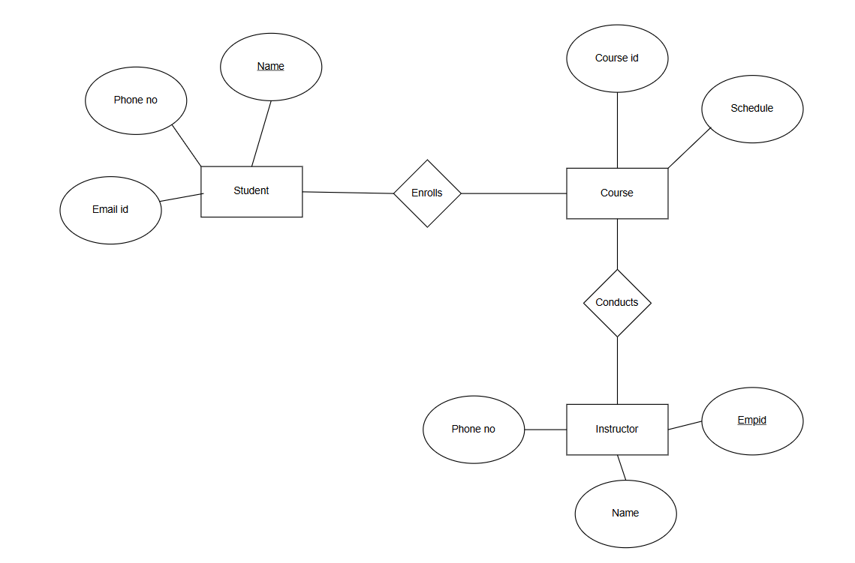
ER Diagram
External Interface Requirements/Screenshots
4.1 User Interfaces

- Student Interface
The Student Interface shall allow users to:
Register and login to the system
Select known language and new language to learn
Browse and enroll in courses
View course materials and schedules
Attend online classes
Submit assignments and quizzes
Make payments for subscriptions
Track learning progress

- Instructor Interface
The Instructor Interface shall allow users to:
Login securely
Create and manage courses
Upload learning materials
Schedule live classes
Assign quizzes and assignments
Evaluate student submissions
View enrolled students

- Administrator Interface
The Administrator Interface shall allow users to:
Manage student and instructor accounts
Approve or remove courses
Manage subscription plans
Monitor payments and transactions
Generate system reports
Manage user roles and permissions

- Payment Interface
The Payment Interface shall allow users to:
Select subscription plan
Enter payment details securely
View payment confirmation
Download payment receipt

4.2 Hardware Interfaces
(The system does not require hardware interfaces)
4.3 Software Interfaces
- Operating System (Windows, macOS, Android, iOS)
- Database Management System (MySQL / MongoDB)
- Web Browser (Chrome, Firefox, Edge, Safari)
- Payment Gateway (Razorpay /PayPal,PhonePe)

4.4 Communication Interfaces
- Internet
- HTTPS protocol for secure communication
- Wi-Fi / LAN network support

Other Non-Functional Requirements

  - Performance Requirements
The system shall meet the following performance standards:
- The system shall respond to user requests within 2–3 seconds under normal load.
- The system shall support at least 500 concurrent users without performance degradation.
- Course pages and dashboards shall load within 3 seconds.
- Payment processing confirmation shall be completed within 5 seconds.
- The system shall handle multiple assignment submissions simultaneously.
- Database queries shall be optimized for fast retrieval of course and user data.

  - Safety Requirements
- Automatic daily database backups.
- Secure cloud storage for learning materials and user data.
- Data recovery mechanisms in case of system crash.
- Error-handling mechanisms to prevent data corruption.
- Validation checks before storing user inputs.
- Transaction rollback in case of payment failure.

  - Security Requirements
- Only authenticated users shall access the system.
- Passwords shall be encrypted using secure hashing techniques.
- All data transmission shall use HTTPS encryption.
- Payment information shall be processed through a secure payment gateway.
- The system shall automatically log out inactive users after a fixed time.
- Protection against unauthorized access.

  - Software Quality Attributes
- The system shall operate with minimal downtime (99% availability).
- The system shall provide a simple and user-friendly interface.
- Navigation shall be clear and intuitive.
- The system shall support future expansion (more courses, users, and instructors).
- The system shall be modular for easy updates and maintenance.
- Code shall follow standard programming practices.
- The system shall run on multiple devices (desktop, tablet, mobile).

  - Business Policies/Rules
- Students must register before enrolling in a course.
- Payment is mandatory before accessing premium courses.
- Instructors can only manage courses assigned to them.
- Only administrators have full control over system management.
Testing
Sample Code 1

White Box Testing
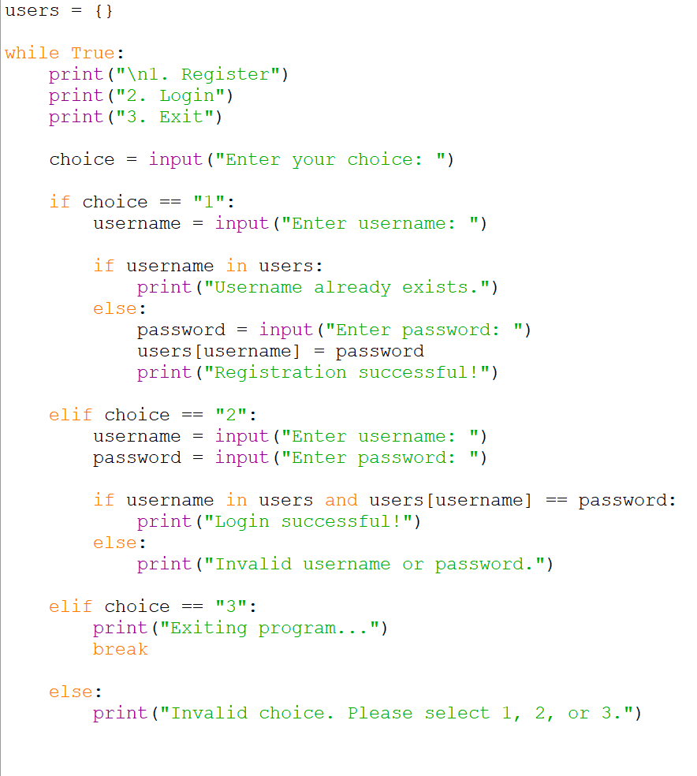
- Control Flow Graph
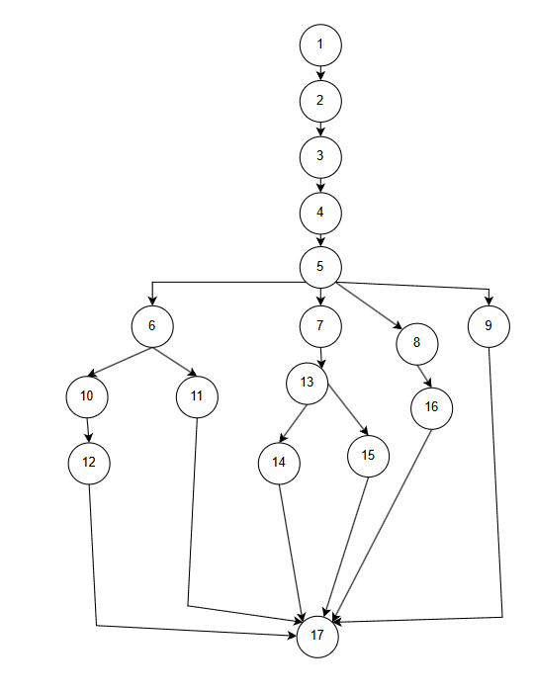
- Cyclomatic Complexity
Here number of Nodes = 17
Number of edges=21
V(G)=E-N+2
=21-17+2=6
- Independent paths
1.Path 1:1-2-3-4-5-6-10-12-17
2.Path2:1-2-3-4-5-6-11-17
3.Path3:1-2-3-4-5-7-13-14-17
4.Path4:1-2-3-4-5-7-13-15-17
5.Path5:1-2-3-4-5-8-16-17
6.Path6:1-2-3-4-5-9-17

- Test cases from independent paths
Path No | Independent Path | Test Input | Expected Output
P1 | 1-2-3-4-5-6-11-17 | [1,”A”] | Registration successful!
P2 | 1-2-3-4-5-6-10-12-17 | [1,”A”,”abc”] | Username already exists
P3 | 1-2-3-4-5-7-13-14-17 | [2,”A”,”abc”] | Login successful!
P4 | 1-2-3-4-5-7-13-15-17 | [2,”B”,”abc”] | Invalid username or password.
P5 | 1-2-3-4-5-8-16-17 | [3] | Exiting program…
P6 | 1-2-3-4-5-9-17 | [4] | Invalid choice. Please select 1, 2, or 3.

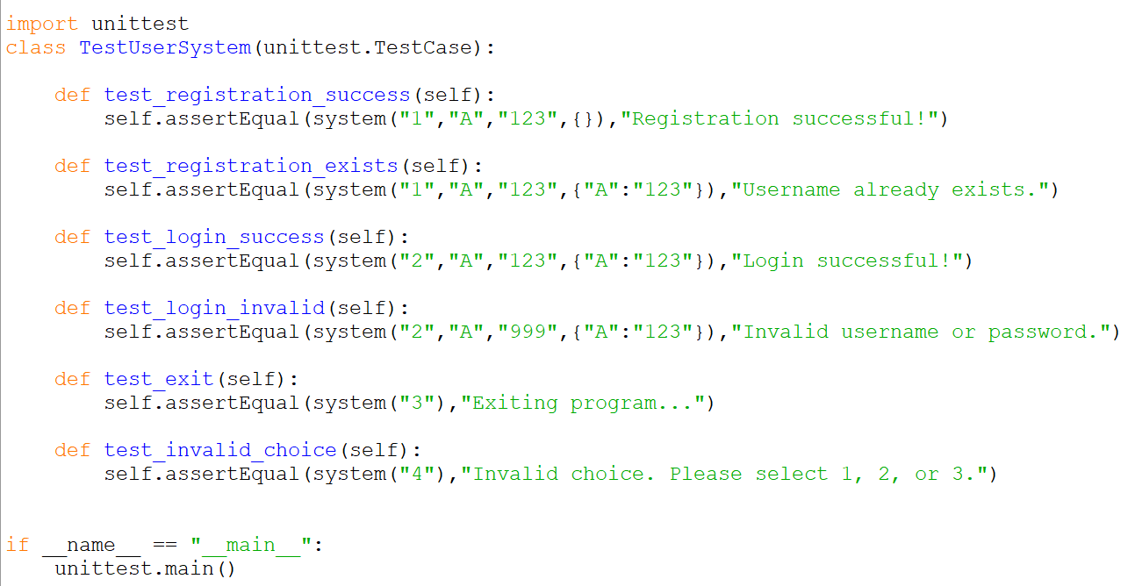
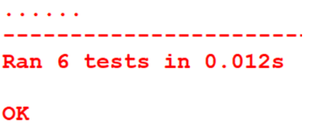

Black Box testing
- Equivalence Partitioning

Username
Class | Condition | Valid/invalid
EC1 | Empty Username | Invalid
EC2 | Valid Username | Valid
Registration
Class | Condition | Valid/invalid
EC3 | Correct Password | Invalid
EC4 | Incorrect Password | Valid

- Boundary Value Analysis
Choice boundary=3
Test values
2,3,4
BB No | Test Input | Expected Output | Technique
BB1 | Choice:1  Username: A | Registration successful! | Valid case
BB2 | Choice:1  Username: A  Password:abc | Username already exists. | Repeated username
BB3 | Choice:2  Username: A  Password: abc | Login successful! | Valid case
BB4 | Choice:2  Username: B  Password: abc | Invalid username or password. | Wrong username
BB5 | Choice:3 | Exiting program... | Valid Case
BB6 | Choice:4 | Invalid choice. Please select 1, 2, or 3. | Boundary 4

Sample Code 2
White Box Testing

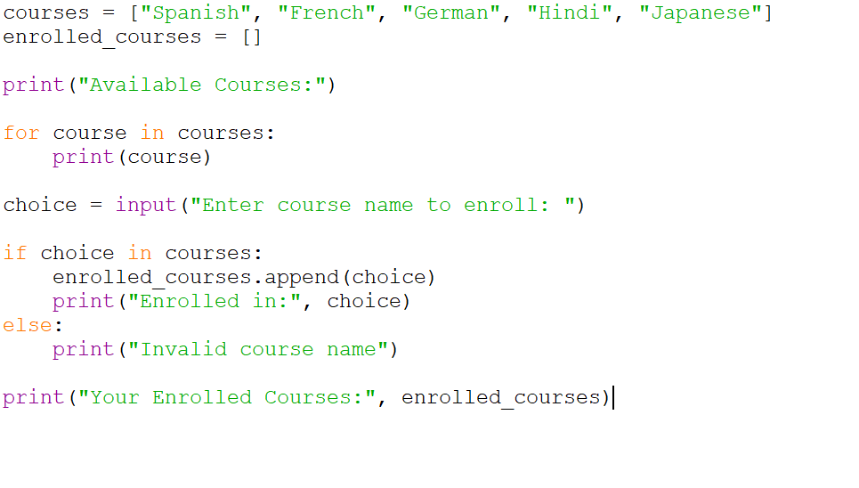
- Control Flow Graph
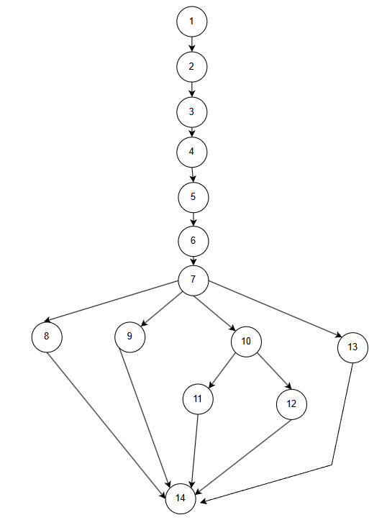
- Cyclomatic Complexity
Here number of Nodes = 14
Number of edges=17
V(G)=E-N+2
=17-14+2=5

- Independent paths
Path1:1-2-3-4-5-6-7-8-14
Path2:1-2-3-4-5-6-7-9-14
Path3:1-2-3-4-5-6-7-10-11-14
Path4:1-2-3-4-5-6-7-10-12-14
Path5:1-2-3-4-5-6-7-13-14

- Test cases from independent paths
Path No | Independent Path | Test Input | Expected Output
P1 | 1-2-3-4-5-6-7-8-14 | [“exit”]
P2 | 1-2-3-4-5-6-7-9-14 | [“ ”] | You entered nothing. Please try again.
P3 | 1-2-3-4-5-6-7-10-11-14 | [“Spanish”] | Successfully enrolled in Spanish
P4 | 1-2-3-4-5-6-7-10-12-14 | [“Spanish”] | You are already enrolled in this course.
P5 | 1-2-3-4-5-6-7-13-14 | [“English”] | Invalid course name. Please select from the list.
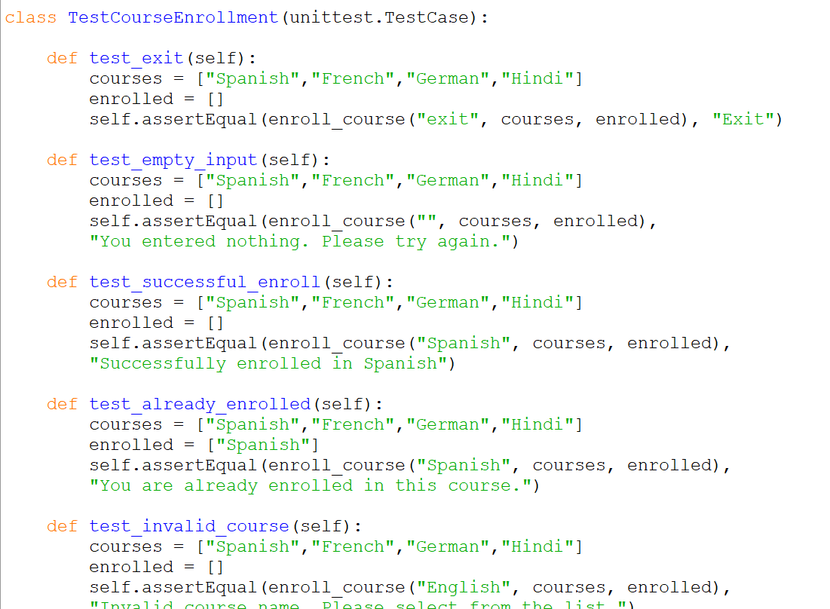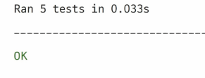

Black Box Testing
- Equivalence Partitioning

Course Name
Class | Condition | Valid/invalid
EC1 | Empty Input | Invalid
EC2 | Other name | Invalid
EC3 | Valid Name | Valid

Boundary Value Analysis
BB No | Test Input | Expected Output | Technique
BB1 | Spanish | Successfully enrolled in Spanish | Valid case
BB2 | Hindi | Successfully enrolled in Hindi | Valid case
BB3 | English | Invalid course name | Course not available
BB4 |  | You entered nothing. Please try again. | Empty
BB5 | exit | Program stops | Valid Case

Conclusion

The Language Learning Portal project was designed to provide an online platform where users can register, log in, enroll in language courses, and interact with instructors. The system includes different modules such as user registration and login, student portal, instructor portal, course enrollment, and payment functionality.

Various software engineering diagrams like DFD, ER diagram, sequence diagrams, activity diagrams, and collaboration diagrams were used to represent the system design and workflow clearly.

In addition, testing techniques such as control flow graphs, path testing, and unit testing were applied to ensure that the system works correctly under different conditions. The project helped in understanding the complete software development process including requirement analysis, system design, implementation, and testing.

Overall, the Language Learning Portal demonstrates how a structured software system can be built to support effective and organized language learning.

References

- GeeksforGeeks
- YouTube
- Google
Acknowledgment

I want to sincerely thank my course instructor for giving me the direction and assistance I needed to finish this project effectively. Their insightful advice made it easier to understand the ideas behind software engineering and software testing.

I also want to express my gratitude to the department and the institution for providing the tools and environment needed to complete this research. Lastly, I would like to thank my friends and classmates for their support and encouragement during the project's development.

Design Architecture

Component-Level Design
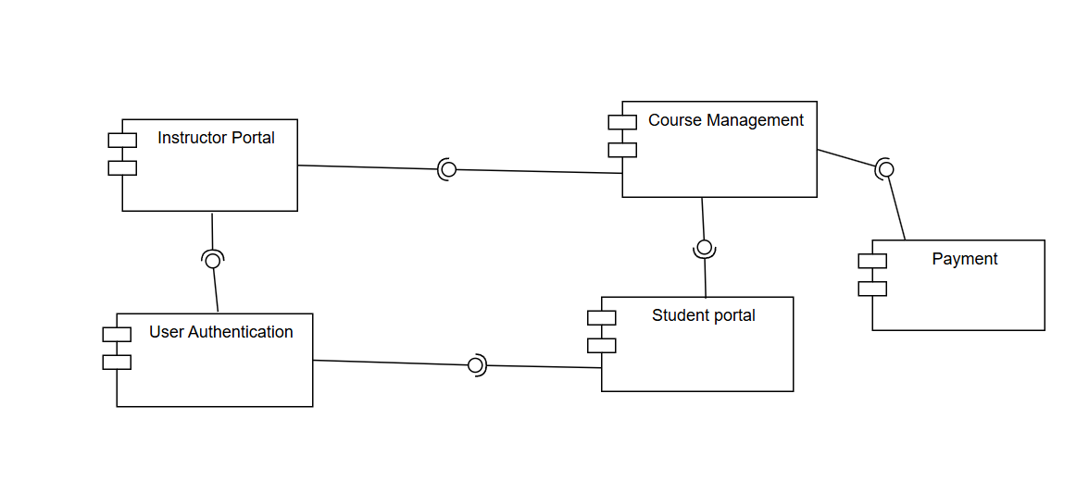

Deployment level design
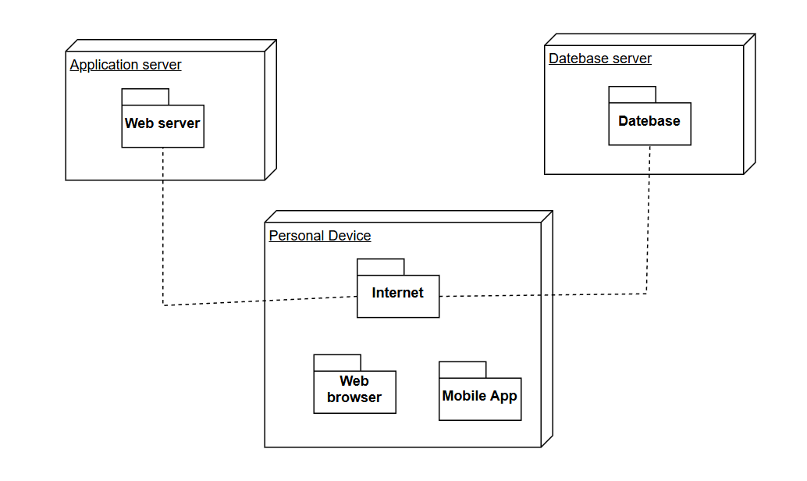

Metrics for analysis model

Language Learning Portal System

Calculate UFP

- Number of External Inputs (EI) (Simple): 8
- Number of External Outputs (EO) (Simple): 5
- Number of External Inquiries (EQ) (Simple): 4
- Number of Internal Logical Files (ILF) (Simple): 5
- Number of External Logical Files (ELF) (Simple): 2

Information Domain Value | Simple | Average | Complex
External Input | 3 | 4 | 6
External Output | 4 | 5 | 7
External Inquiries | 3 | 4 | 6
Internal Logical Files | 7 | 10 | 15
External Logical Files | 5 | 7 | 10

UFP= (8*3)+(5*4)+(4*3)+(5*7)+(2*5)
= 24 + 20 + 12 + 35 + 10 = 101

Calculate CAF

CAF= 0.65 + ( 0.01* ∑ ( F_{i} ))

- Does the system require reliable backup and recovery?
4
- Are specialized data communications required to transfer information to or from the application?
4
- Are there distributed processing functions?
3
- Is performance critical?
4
- Will the system run in an existing, heavily utilized operational environment?
3
- Does the system require online data entry?
5
- Does the online data entry require the input transaction to be built over multiple screens or operations?
4
- Are the ILFs updated online?
5
- Are the inputs, outputs, files, or inquiries complex?
3
- Is the internal processing complex?
3
- Is the code designed to be reusable?
3
- Are conversion and installation included in the design?
2
- Is the system designed for multiple installations in different organizations?
4
- Is the application designed to facilitate change and ease of use by the user?
5

∑(F_{i})= 4+4+3+4+3+5+4+5+3+3+3+2+4+5= 52

CAF = 0.65 + (0.01* 52)
= 0.63 +0.52 = 1.17

Calculate FP
FP= Total Count (UFP) * CAF
= 101 * 1.17 = 118.17

Hours of Deployment and Developer Cost
1 FP = 10 hours
Therefore, 118.17 FP = 118.17 * 10 = 1181.7
1181.7 hours of deployment

Developer cost = ₹1000 per hour
= 1000 * 1181.7 = ₹11,81,700
Estimated project cost = ₹11,81,700

Empirical Estimation Models-COCOMO Model

COCOMO Model
COCOMO (Constructive Cost Model) is a regression model based on the number of Lines of Code (LOC). It is a procedural cost estimation model for software projects.
This model is used for predicting the various parameters associated with developing a project such as size, effort, cost, and time.
i) Project Category - Organic.
“The estimated size of the Travel Hive system is approximately 12 KLOC”
ii) Types of COCOMO Models.
1) Basic COCOMO model - Predicted software size (lines of code) is used to estimate development effort.
2) Intermediate COCOMO model - Predicted software size (lines of code), along with a set of 15 subjectively assessed “cost drivers,” is used to estimate development effort.

- Basic COCOMO Model
The following formulas are used to calculate effort and time estimates:
Effort (E) = A * (KLOC) ^B
Time (T) = C * (Effort) ^D
Persons required = Effort / Time

The constant values A, B, C and D for the Basic Model for the Semi-Detached category of software project is:
Software Project | A | B | C | D
Semi Detached | 3.0 | 1.12 | 2.5 | 0.35
Estimated size ≈ 12 KLOC

Effort (E) = A * (KLOC) ^B
E= 3.0 * (12)^1.12
E= 3.0 * 16.3
E= 48.9 Person-Months

Time (T) = C * (Effort) ^D
T=2.5 * (48.9)^0.35
T=2.5 * 3.2
T= 8 Months

Persons required = Effort / Time
= 48.9/8
≈ 6 Developers

- Intermediate COCOMO Model
- Product Attributes:
1.Required software reliability extent: High
2.Size of the application database:High
3.The complexity of the product:High
- Hardware attributes:
4.Run-time performance constraints:High
5.Memory constraints:Nominal
6.The volatility of the virtual machine environment:Nominal
7.Required turnabout time:High
- Personnel attributes:
8.Analyst capability:Nominal
9.Software engineering capability:Nominal
10.Applications experience: Low
11.Virtual machine experience:Nominal
12.Programming language experience:Nominal
- Project attributes:
13.Use of software tools:High
14.Application of software engineering methods:High
15.Required development schedule: Nominal

Cost Drivers Number | Very Low | Low | Nominal | High | Very High | Extra High
1 | 1.75 | 0.88 | 1.00 | 1.15 | 1.40 | -
2 | - | 0.94 | 1.00 | 1.08 | 1.16 | -
3 | 0.70 | 0.85 | 1.00 | 1.15 | 1.30 | 1.65
4 | - | - | 1.00 | 1.11 | 1.30 | 1.66
5 | - | - | 1.00 | 1.06 | 1.21 | 1.56
6 | - | 0.87 | 1.00 | 1.15 | 1.30 | -
7 | - | 0.87 | 1.00 | 1.07 | 1.15 | -
8 | 1.46 | 1.19 | 1.00 | 0.86 | 0.71 | -
9 | 1.29 | 1.13 | 1.00 | 0.91 | 0.82 | -
10 | 1.42 | 1.17 | 1.00 | 0.86 | 0.70 | -
11 | 1.21 | 1.10 | 1.00 | 0.90 | - | -
12 | 1.14 | 1.07 | 1.00 | 0.95 | - | -
13 | 1.24 | 1.10 | 1.00 | 0.91 | 0.82 | -
14 | 1.24 | 1.10 | 1.00 | 0.91 | 0.83 | -
15 | 1.23 | 1.08 | 1.00 | 1.04 | 1.10 | -

EAF = 1.15*1.08*1.15*1.11*1*1*1.07*1*1*1.17*1*1*0.91*0.91*1
EAF = 1.65
Software Project | A | B | C | D
Semi Detached | 3.0 | 1.12 | 2.5 | 0.35

Effort ( E ) = (A*(KLOC)^B ) * EAF.
E= (3.0 * (12)^1.12 ) * 1.65
E= 80.7 ≈ 81 Person-Month
Time (T) = C*(Effort)^D
T = 2.5 * (80.7)^ 0.35
T= 9.5 ≈ 9-10 Months

Persons required = Effort / Time
80.7/ 9.5 = 8.5 ≈ 9 Persons

